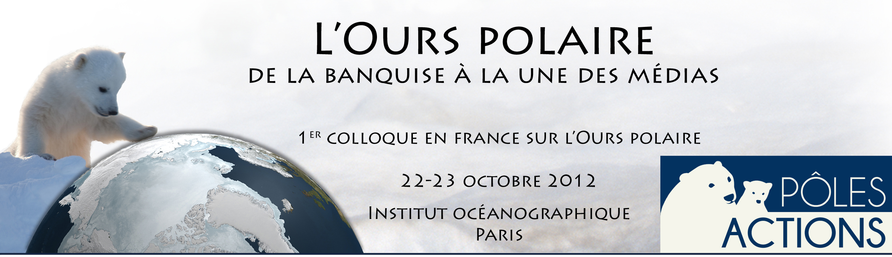

The polar bears of the Barents Sea : population size and habitat use

AARS Jon

Norwegian Polar Institute - Fram Centre
9296 OSLO - NORWAY

The archipelagos of Svalbard (Norway) and Franz Josef Land (Russia), and the sea areas between and to the north of these islands, host the Barents Sea polar bear population. The delineation of this population is based on a combination of satellite telemetry data, capture-recapture data, and genetic structure. After about a century of hunting in the Norwegian sector, leading to over-exploitation, polar bear hunting in the area has been prohibited since 1973. It has long been a demand for an estimate of the size of the Barents Sea polar bear population, not least for management purposes and to provide the possibility of monitoring future trends in population growth. In August 2004, such a survey was conducted. One helicopter covered the largest land areas of Svalbard. A second helicopter operated from a research vessel platform, and covered areas with sea ice, including the ice edge, and the Franz Josef Land archipelago. Although total count of bears was employed locally in some areas, most survey areas were covered by line transects. From the lines, bear-line distances are measured and used to calculate densities of bears within different areas and habitats. We got a total estimate of 2650 bears for the Barents Sea population.
Satellite telemetry collars have had large significance for what we know about the Barents Sea polar bears. They have clearly shown that there are two very different habitat strategies, some bears roam over large areas while others stay at or close to the islands year around. The data has shown us that the bears prefer sea ice over shallow water, and that which areas they use depends on season and the type of sea ice present. Most bears from Svalbard walk east or north-east if they leave the islands, to areas with shallow and productive waters. The last generation of satellite telemetry collars provide data much more frequent and with more exact positions than earlier. This allows us to study behavior to a larger detail than what has earlier been possible. Fine scale data has shown that particularly females with small cubs stay close to the glacier fronts much time in April, where they can hunt ringed seal pups, while other females also use areas further off-shore to a larger extent.

