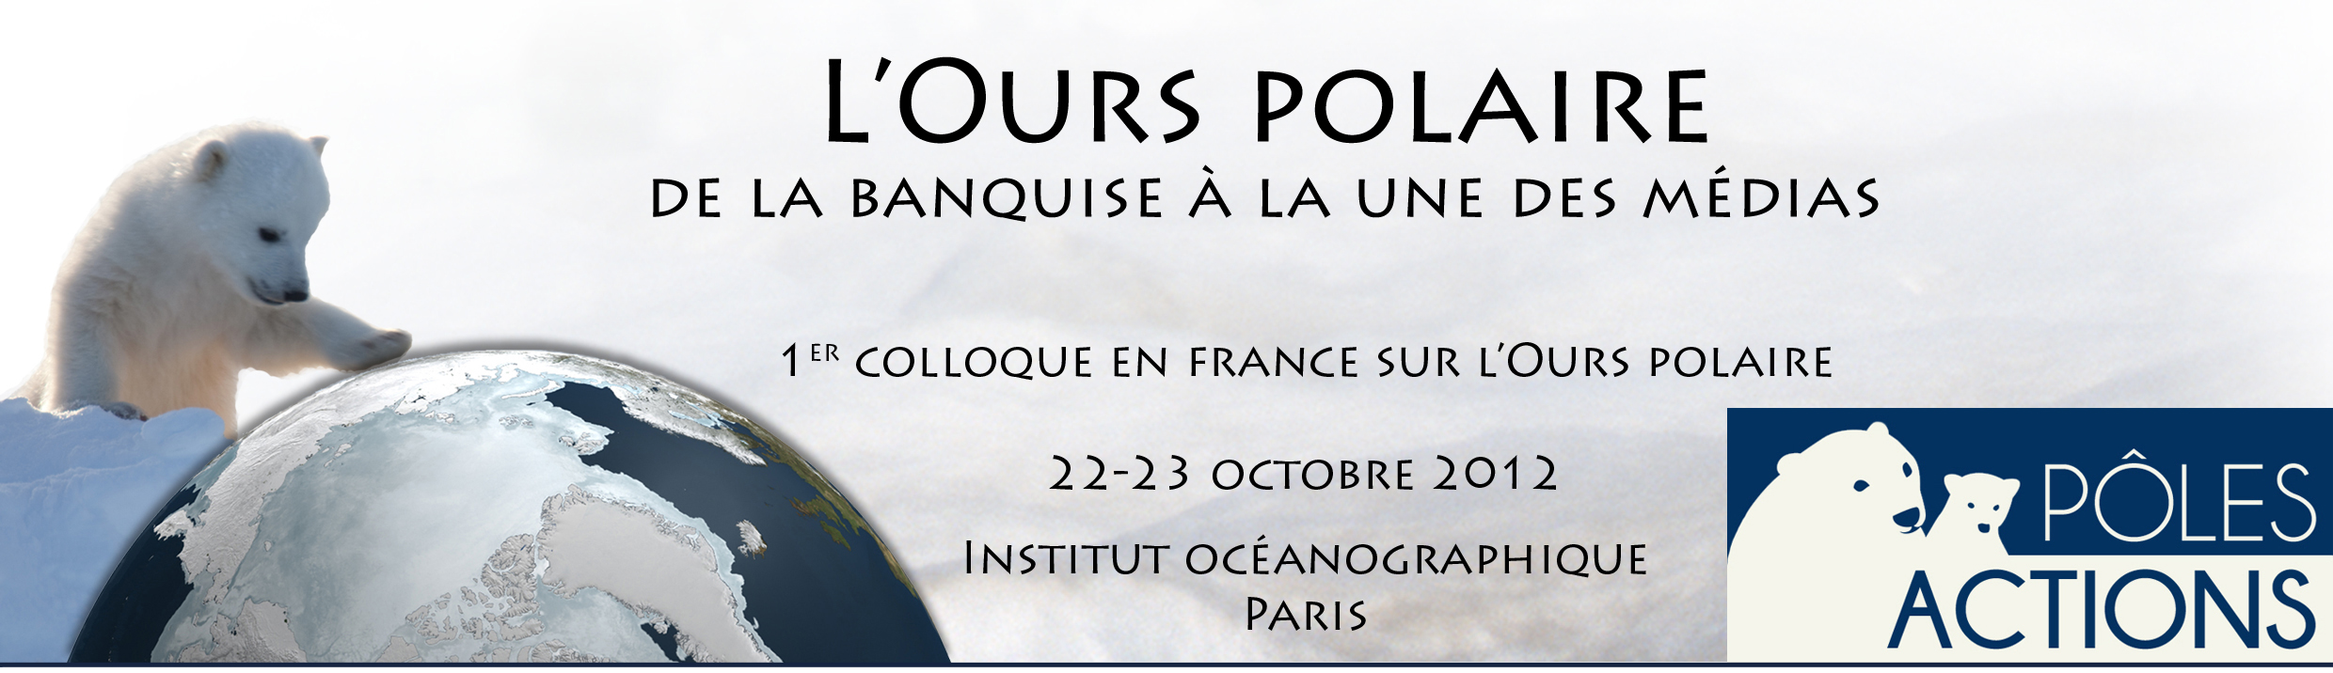

The fate of an Arctic icon

DEROCHER Andrew

CW405 Biological Sciences Centre - University of Alberta
T6G 2E9 EDMONDTON - AB CANADA

The effects of global warming on polar bears (Ursus maritimus) are clear and the fate of polar bears is little different than any other highly specialized species affected by habitat loss. The rapid disappearance of sea ice habitat has resulted in significant and well-documented alteration of population demographics. Earlier spring break-up and later autumn ice formation are the main stress points for populations but habitat fragmentation is also a concern. The earliest indicator in affected populations is a loss in body condition that triggers declines in reproduction and survival. While changes observed in polar bear populations have been gradual to date, there is concern that thresholds, once crossed, will lead to precipitous population declines. With 19 populations of polar bears in the circumpolar Arctic, the expected changes will occur at different temporal scales but by mid-century, several subpopulations will be extirpated and two-thirds of the global population may be gone. Observed changes in populations have been gradual but once ecological thresholds are crossed, precipitous declines are likely. To date, no country has developed adequate management plans to deal with polar bear conservation.

